Wiki – Group Web Pages – Classroom or Project Workspace

Easier to develop than a Web site. No need for HTML.
Pages link easily.
Many authors in the shared space.

For the NERC11 session, we'll be using the Wikispaces tool. I've set up a “wiki workspace” in which you will begin your practice. After that, you may create your own.

You will first need a Wikispaces account.

Go to the practice wiki page: http://nerc-train.wikispaces.com

Click the “Join this Wiki” link

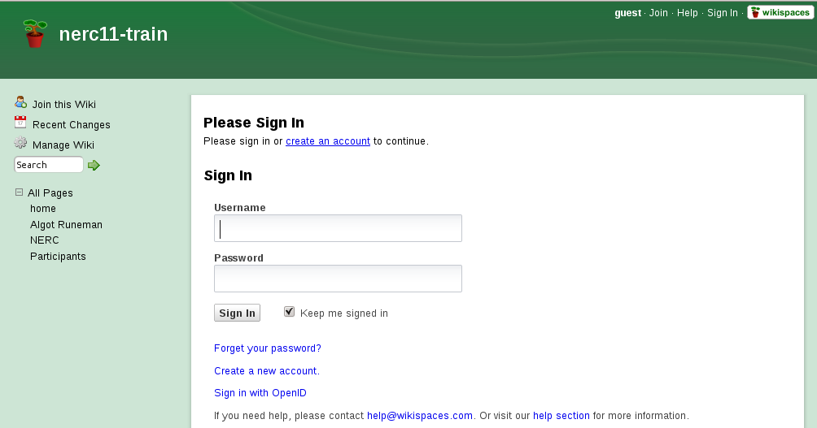
Then click “create an account.”
(unless you already have an account)

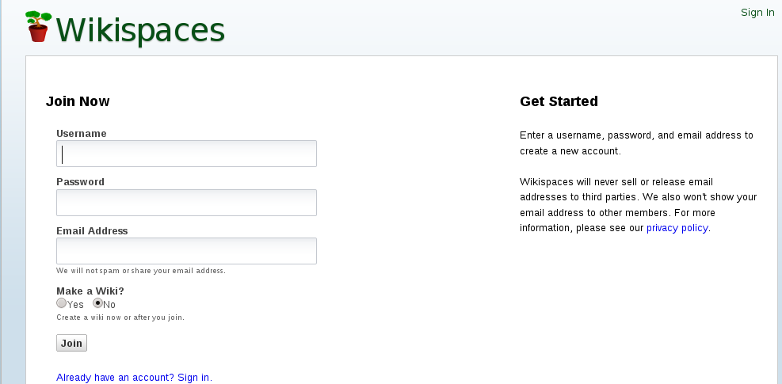
Initially, I'll have you work with the Wiki I've set up for the NERC11 session.

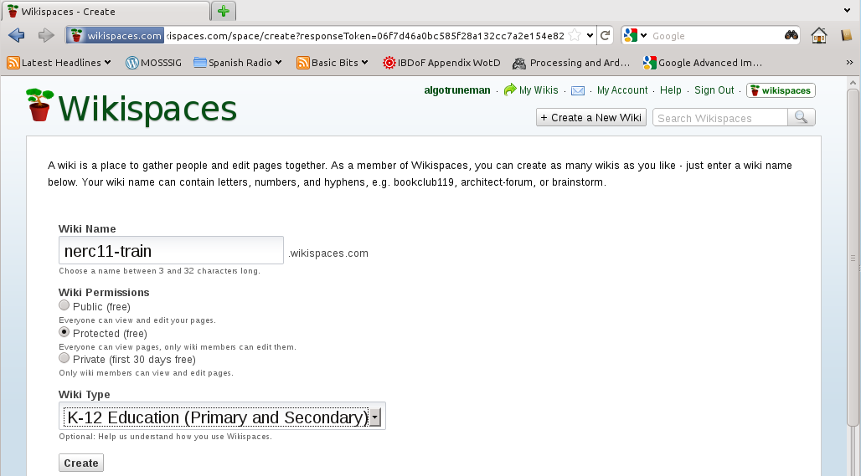

http://nerc11-train.wikispaces.com

There are helpful video tours to watch.
http://www.wikispaces.com/site/tour

Read the information on the next pages for a general description which you will get if/when you start your own wiki. The pages are images from the “Getting Started” screen presented during the setup of a new wiki.

The activities for your work time during the NERC Web Tools session are outlined on the Wiki home page (sneaky way to get you into the Web/cloud work process).
http://nerc11-train.wikispaces.com/#Getting%20Started%20with%20Your%20Wiki

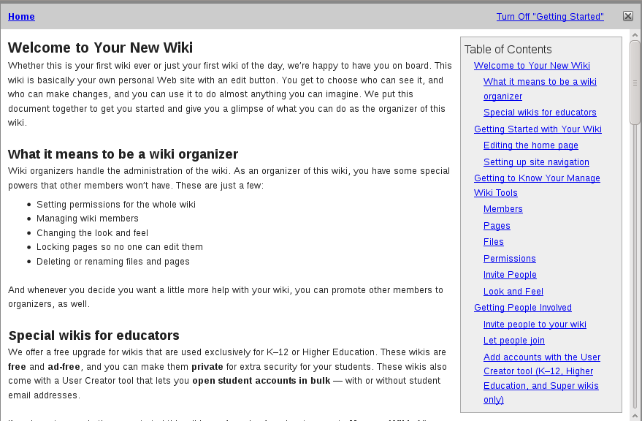
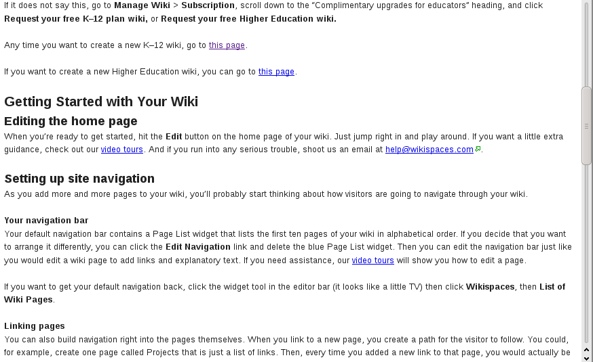
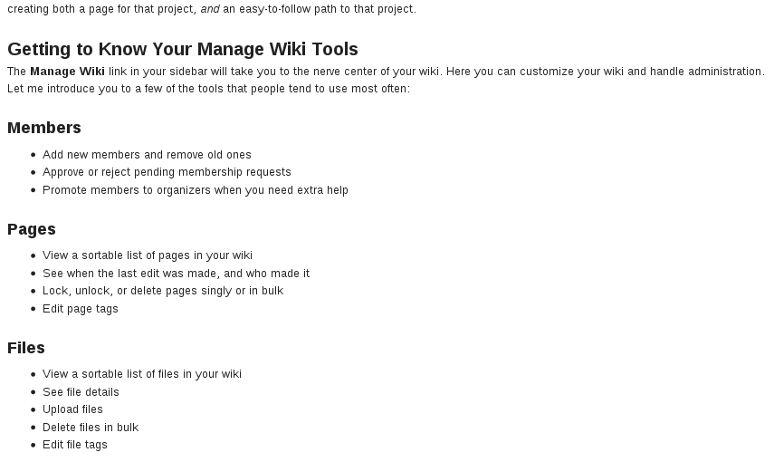
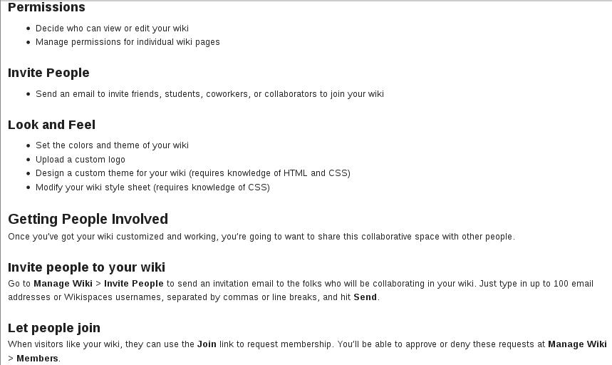
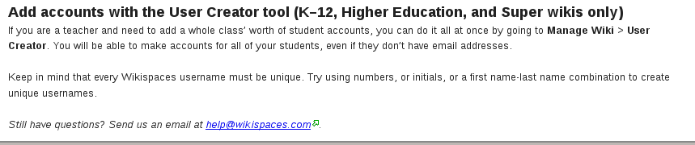

The contents of this document free to use with Attribution.

