Twitter – Short Form Communication – Professional Learning Network
One hundred and forty characters.
140 including spaces.
Not much room, but often just enough.
Will it replace email?
No. But email may no longer be the first choice for passing a quick message to someone.
Will you write a novel on Twitter?
I doubt it.
Will I get connections with tens, hundreds, thousands of compatible social studies professionals?
Quite possibly. Twitter can connect you to a very useful PLN.


Signing Up
Enter the Twitter address into your browser location bar. http://twitter.com
*Click the Sign Up button. (Come back to “Discover Twitter” as you have time.)
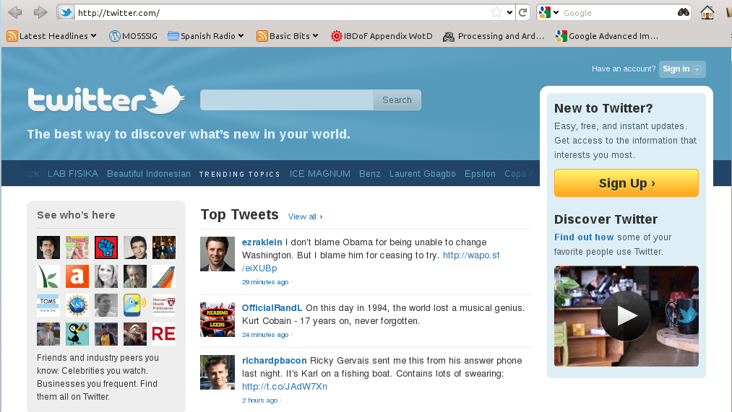

*Enter the requested information into the signup form.
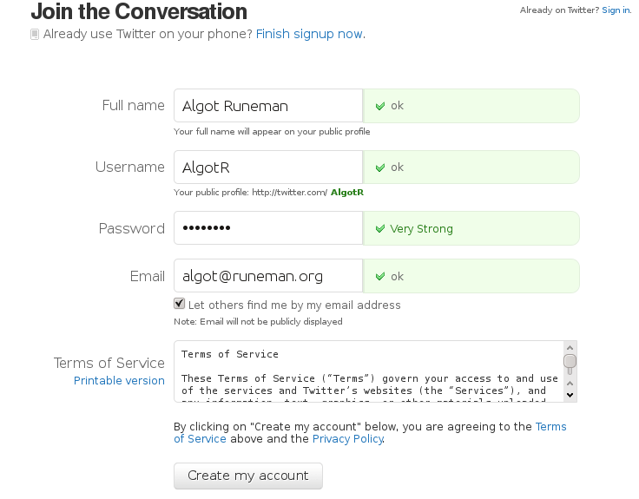

What if somebody already has the name I want?
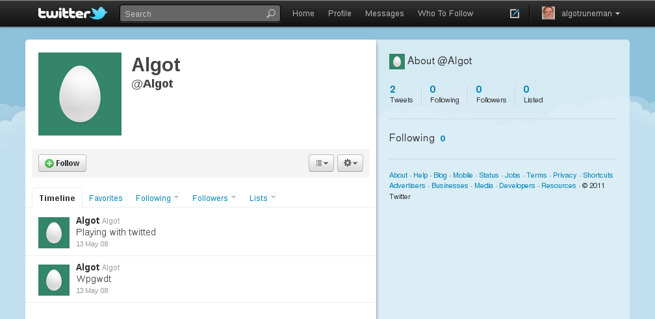
Work around the name issue, “Bob” is certainly going to be taken. I was surprised to find my own unusual first name had been used (even though apparently abandoned).

My main Twitter ID is @algotruneman. Or try adding a number-algot1, algot557.
There's no email verification delay. You are “in” right away.
You will get an email to verify, but you can get started before you answer it. (see second image below)
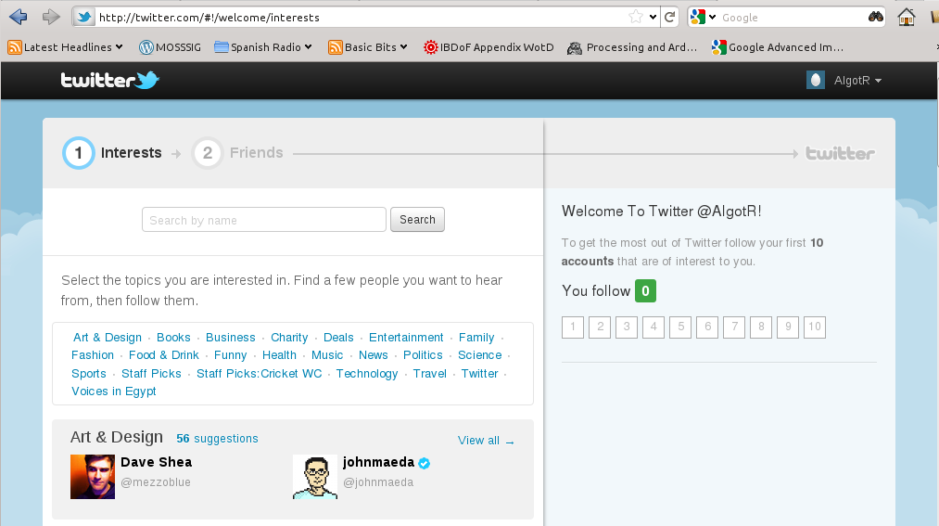
Email confirmation:
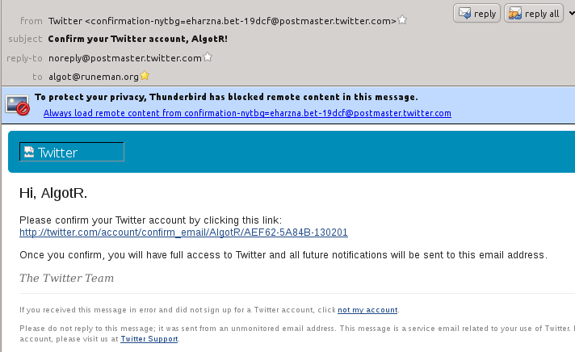
*Click this link. It confirms you want the account fully active. Your browser will open to your “home” page.
(see next illustration below)

This is your “home” page. This is the page you will see when you log in each time.
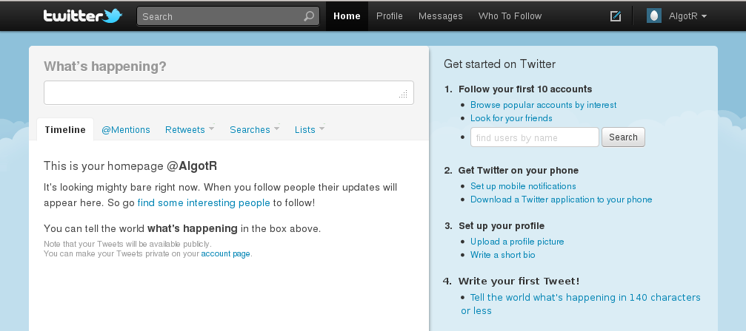
On the home page you see messages which match the interests you have developed. It won't show much until you follow some people.
Two immediate follows:
@algotruneman which is my primary account and @AlgotR, the account I set up for this document and the NERC session. I'll be responding during the session at NERC. Twitter is a good “backchannel.”
*Share your Twitter user name with the others in your group. Advertise more widely, send a note to the mailing list with the topic Twitter.
*Send messages today (and later – for follow up) which include the hashtag #nerc11-train which will be a way to keep in quick contact with the others at this NERC session.
Hashtags are terms which begin with the “#” symbol, a hash symbol (also known as number symbol).
Use hashtags to focus your Twitter comments in a way that helps others. If you use an appropriate hashtag, others will find your comment more easily.
I recommend keeping track of the conversations on #edchat and #sschat among others.
If you find good hashtags, pass them along. Remember, this is part of a Professional Learning Network (PLN).
Twitter isn't a reliable method to replace email. People need to remember to check it by going to the Twitter page. Some people are following so many others that your tweet will get lost. Email is directed.
*Follow others. I strongly urge you to follow @gregkulowiec, a social studies teacher at Plymouth High School here in Massachusetts. He's done presentations at NERC (including this year). Go to that user's Twitter page by doing a search for them by user name. Once you get their page, click the link for “follow” and their tweets will begin appearing on your “timeline” on your Twitter page.
Others:
@21stprincipal, @DianeRavich, @tomwhitby (add your recommendations in the Twitter discussion on the email list.)
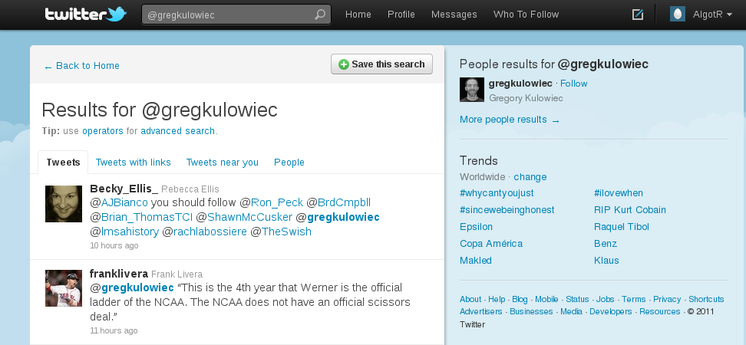

Activities:
- Update your profile. (Ask about photo.)
- Explore each of the links on your Twitter home page.
- Sign out and back in.
(Note that you can set the login to be remembered, but you may not want to do that if others share your computer. Connecting to Twitter if you have asked Twitter to “remember me”, your password will be pre-entered, and anybody using your computer can use your Twitter account to send messages from your computer.”)
- Tweet what you learn. (If this is a professional effort, avoid too many “I ate pancakes for breakfast” tweets. Be personal, but not too trivial.
- Tweet a question to @algotruneman (Note that the @ symbol is important!)
- Examine the difference between a regular tweet to someone and a “direct message.”
- Find out about “lists.”
- What is a “retweet”? (What does it say about you when you retweet a message?)
- Tweet someone a Web link from a Web page (copy/paste). Find out about “url shortening.”
- Share, share, share.
- Do Google search and explore advanced tools like HootSuite, Twitpic, Tweetdeck, etc.
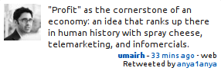
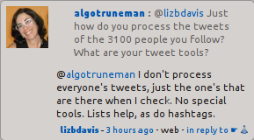

The contents of this document free to use with Attribution.

Tweets you might find useful.
RT @CreatvEmergence: "To be prepared against surprise is to be trained. To be prepared for surprise is to be educated." ~ James Carse


