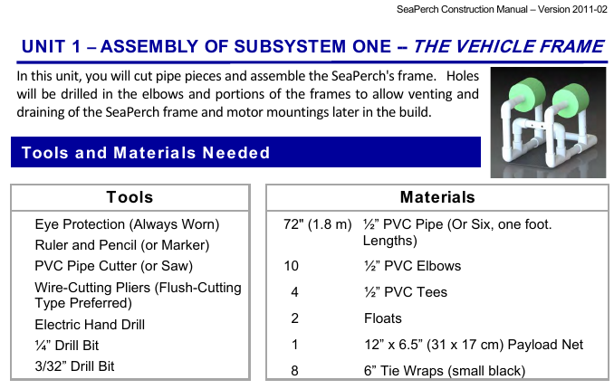

The kits from the Seaperch organization are $155 for all that is needed to construct the ROV.
The idea is to encourage young people to get fully involved in the building, testing and use of the Seaperch.

If the group is interested, we'll try making a couple of frames during the meeting.

There will be one set of cut and drilled parts to assemble.

Somebody with glasses should do the cutting of the pipe (SAFETY FIRST!)

These parts were not from the official kit.. The pipe materials are from Lowes and can also be purchased from Home Depot. The electric motors may be available from Radio Shack or from online order. The section of the manual dealing with the motor housings and also the electronics is not reproduced here.

If members are interested, we can consider purchasing a couple of kits to build together.



