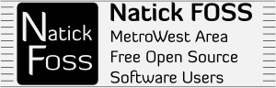

Desktop Choices

Dick Miller is a fan of the mainline Ubuntu Desktop which currently features Unity for the layout and options visible after a login.

Algot Runeman is a fan of the alternative Kubuntu flavor of Ubuntu which features the KDE Plasma Desktop. Those have both been demonstrated in several meetings of Natick FOSS.

These notes accompany demonstrations of a few less-well-known desktops.

Xubuntu – featuring Xfce 

“Xfce is a lightweight desktop environment for UNIX-like operating systems. It aims to be fast and low on system resources, while still being visually appealing and user friendly.” (from the Web site http://www.xfce.org/ )

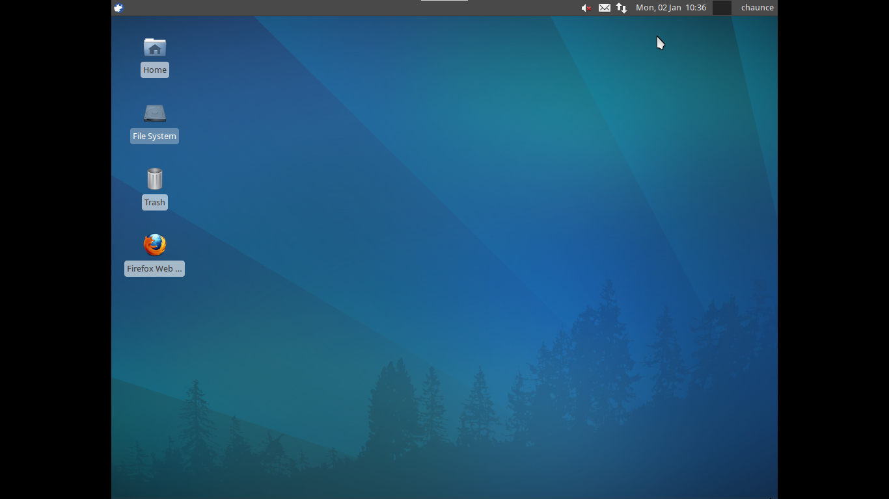

- Similar in appearance to the Gnome or Microsoft Windows desktop (active icons laid out in a grid)
- Double click for activating an icon on the desktop
- Panel for main settings options along the top (can be made vertical at left)
- “Start” applications menu is in common location at left end of the panel
- The base install of tools is lightweight, but you may also choose to add applications through the package management tool, the Ubuntu Software Center.

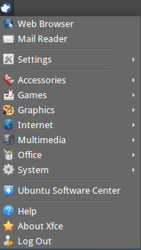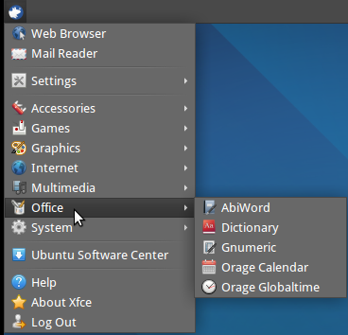

AbiWord is the word processor installed by default. It is able to handle a typical load of word processing, but does not require as many computer resources as the more well-known LibreOffice. AbiWord is not built into a “suite.” You may also notice in the right-hand graphic, that there is a program called Gnumeric. It is the spreadsheet program installed with Xcfe.
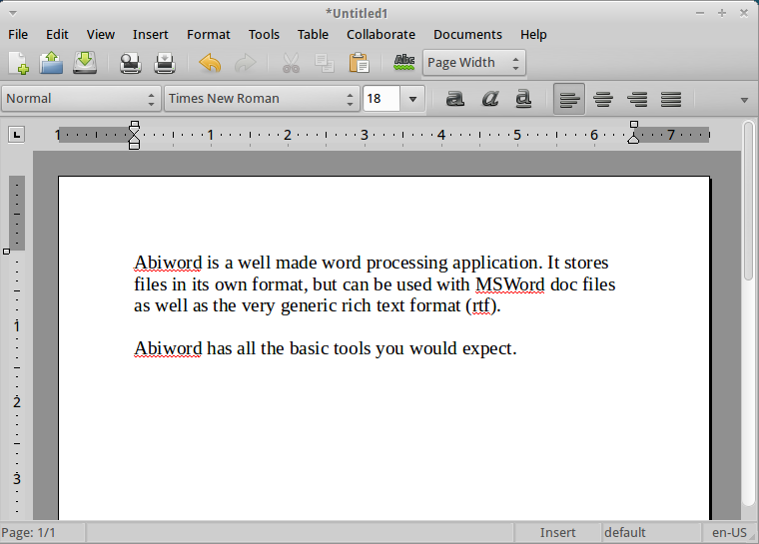

You might ask, what would the main reason be for using applications like AbiWord or Gnumeric instead of the equivalent components of the LibreOffice suite. Xubuntu with Xfce is a distribution designed for older or less powerful computers. You can accomplish most of the same tasks using the alternative applications, or you can add full-strength suites at a penalty. The more resources needed, the slower an application will run. Therefore, as a way to increase speed without significant loss of function, people with older computers often decide to upgrade to Xcfe and its nimble applications instead of Gnome, Unity or KDE with their integration and fancier “eye candy” effects.

..
Lubuntu featuring LXDE “Lightweight X11 Desktop Environment”


“The objective of the lubuntu project is to create a faster, more lightweight and energy saving variant of Ubuntu by using LXDE, The Lightweight X11 Desktop Environment, as its default GUI.” (From the Lubuntu Web site http://lubuntu.net/ )

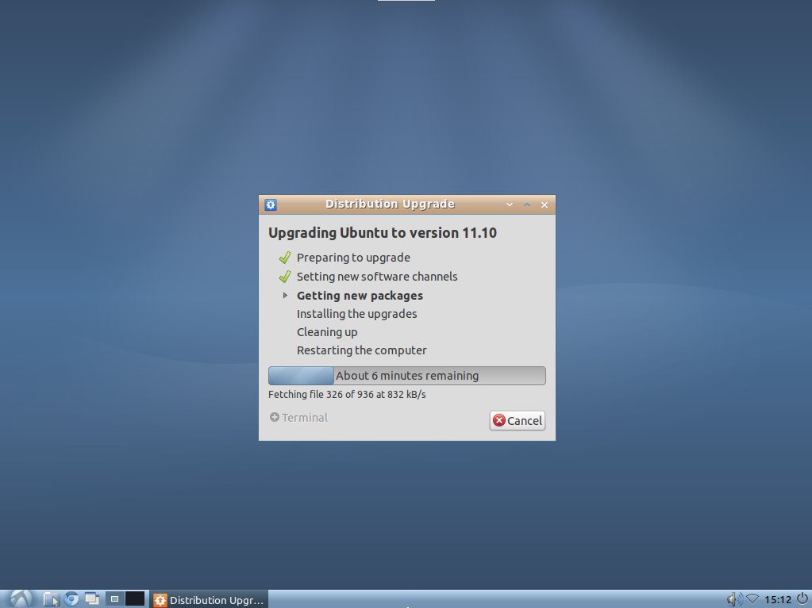

Note that the panel is at the bottom of the screen. The screen capture shows that there is a typical upgrade process which has worked well with these modern versions of the Ubuntu line.

The “Start” menu is at the left end of the panel and you might note that only the clock shows, while Xubuntu in an earlier screen shot showed the date, too. The Chromium (open source version of Google Chrome) browser is the default way to access the World Wide Web (Internet).

There are fewer applications installed with Lubuntu than with Xubuntu. The two main office applications are the same, however, AbiWord and Gnumeric. Osmo is a personal organizer, which includes calendar, task manager and address book modules.

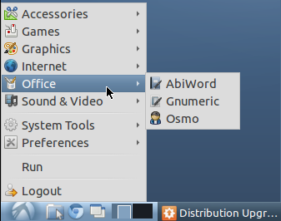

The graphics tools are lightweight, even compared to Xubuntu which included GIMP. The image editor of Lubuntu is mtPaint.

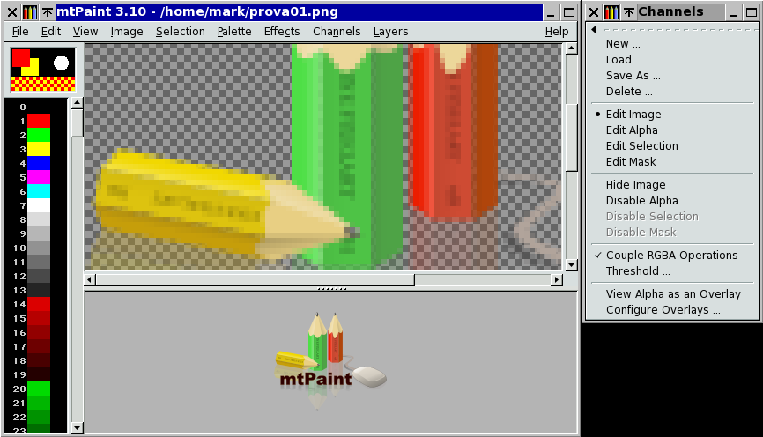

Sugar something really different

Sugar is the interface for the project called One Laptop Per Child (OLPC) which was started a few years ago at MIT.

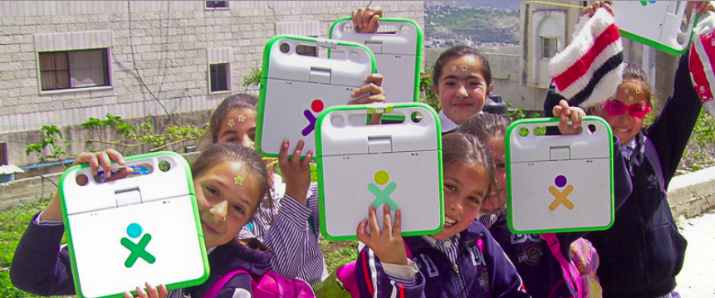

Sugar isn't designed as a direct replacement of a regular computer experience. It is based around the activities a child might do while being a learner. There are activities for writing, communicating, taking pictures and underlying it all is the source code. Most of Sugar is developed in Python and the source code is right there for children to modify, adding new activities and learning computing at a deeper level.

Sugar Labs, the developers of the Sugar interface separated from the OLPC to expand its potential beyond the OLPC laptops. They were designed for distribution to children in developing countries, not for distribution to the US or European countries.

An interesting feature of Sugar is that it is being “sold” (distributed) primarily in the form of “live” USB sticks. http://wiki.sugarlabs.org/go/Sugar_on_a_Stick so it can be introduced for use in any school using any PC with the ability to boot from USB.



